Lab 7 - Configure Assignment methods and rules for queues

Introduction:
In this lab, you will learn how to configure work assignment and prioritization rules in the Copilot Service admin center. These rules help automate how cases are prioritized and assigned to agents based on defined business logic, such as issue priority, user skills, presence status, and working schedules. By creating these rules, you can ensure that work items are distributed efficiently and fairly among available agents.
- In the Copilot Service admin center, navigate to the site map and select Queues under Customer support group.
- On the Queues page, select Manage next to Advanced queues.
- 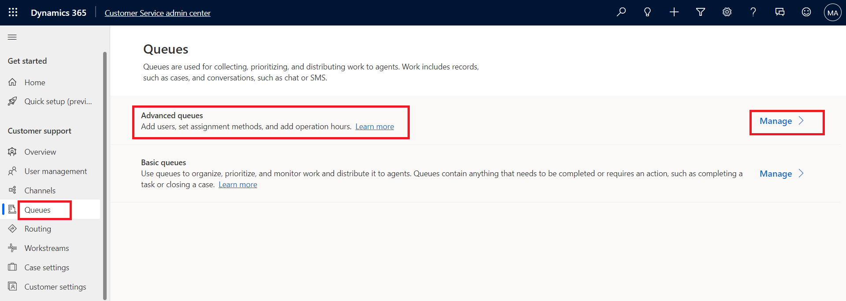
- Select Contoso queue for supervisors.
- 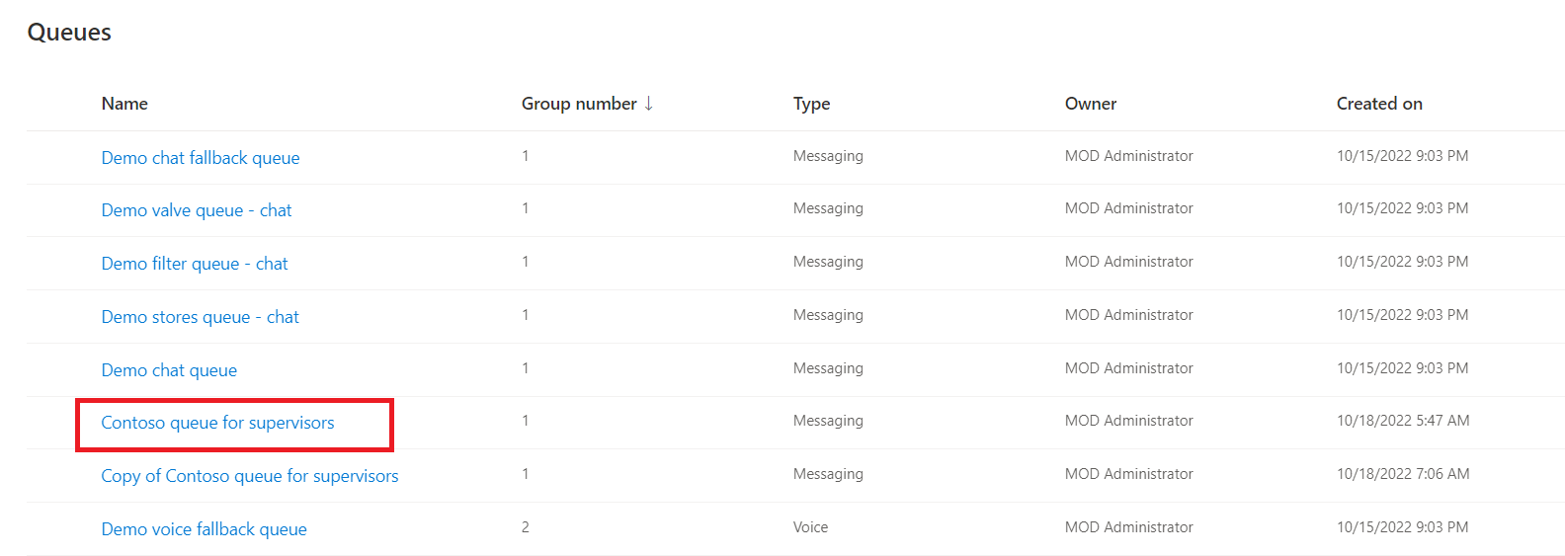
- On the Contoso queue for supervisors, click See more next to Assignment method.
- 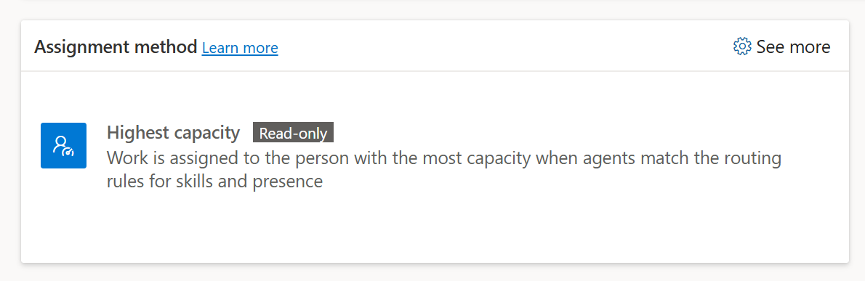
- On the Assignment method page, select Create New.
- 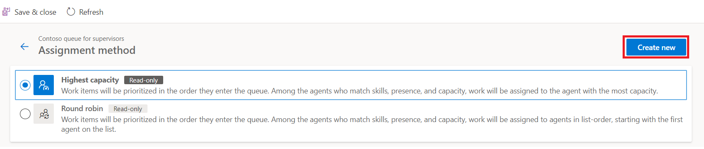
- In the Create work assignment dialog, enter !!Contoso work assignment!! in the Name field and Description field and then select Create.
- 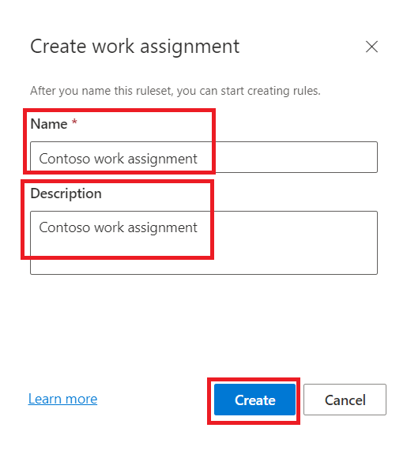
- On the Prioritization Ruleset area, click + Create ruleset.
- 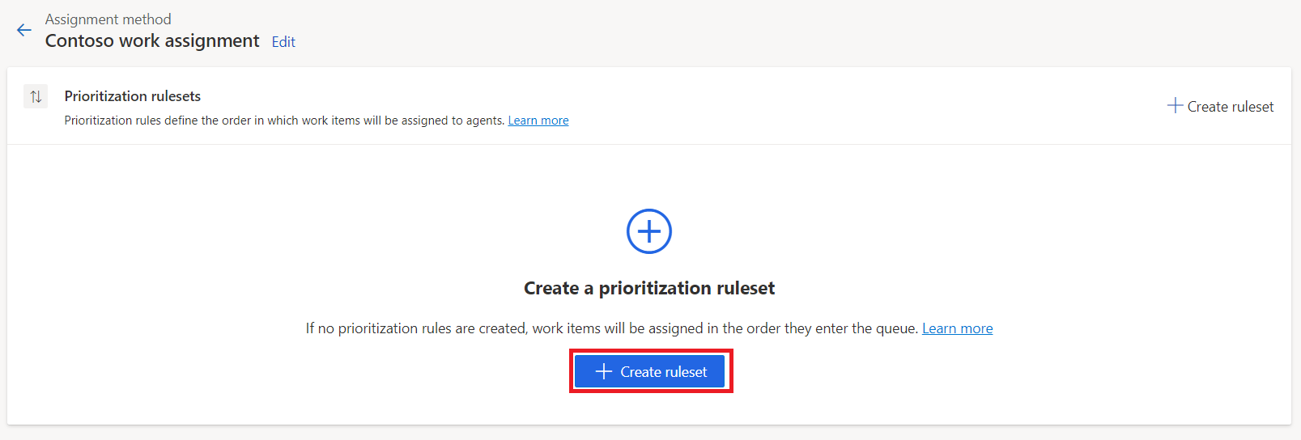
- On the Create Prioritization Ruleset dialog, enter !!Contoso prioritization ruleset!! in the Name field and Description field.
- Select Create.
- 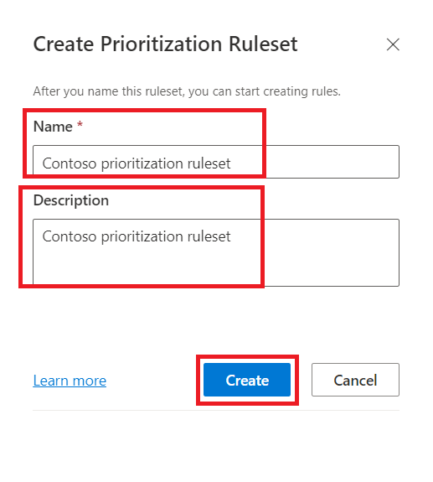
- On the Contoso prioritization ruleset page, in the Decision list area, select + Create rule.
- 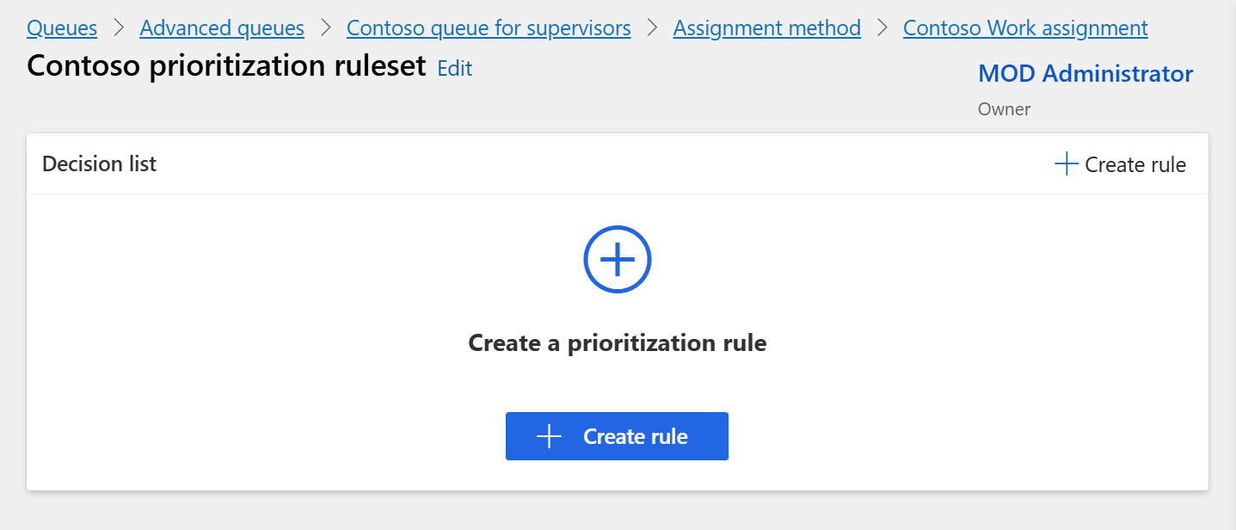
- On the Create Prioritization Rule Dialog, enter !!Contoso prioritization rule!! in the Name field.
- Select + Add and then select Add related entity.
- Add Issue (Case) entity in the first block.
- Create the following condition: Priority Equals High.
- In the Order by area, select First in first out.
- Click Create.
- 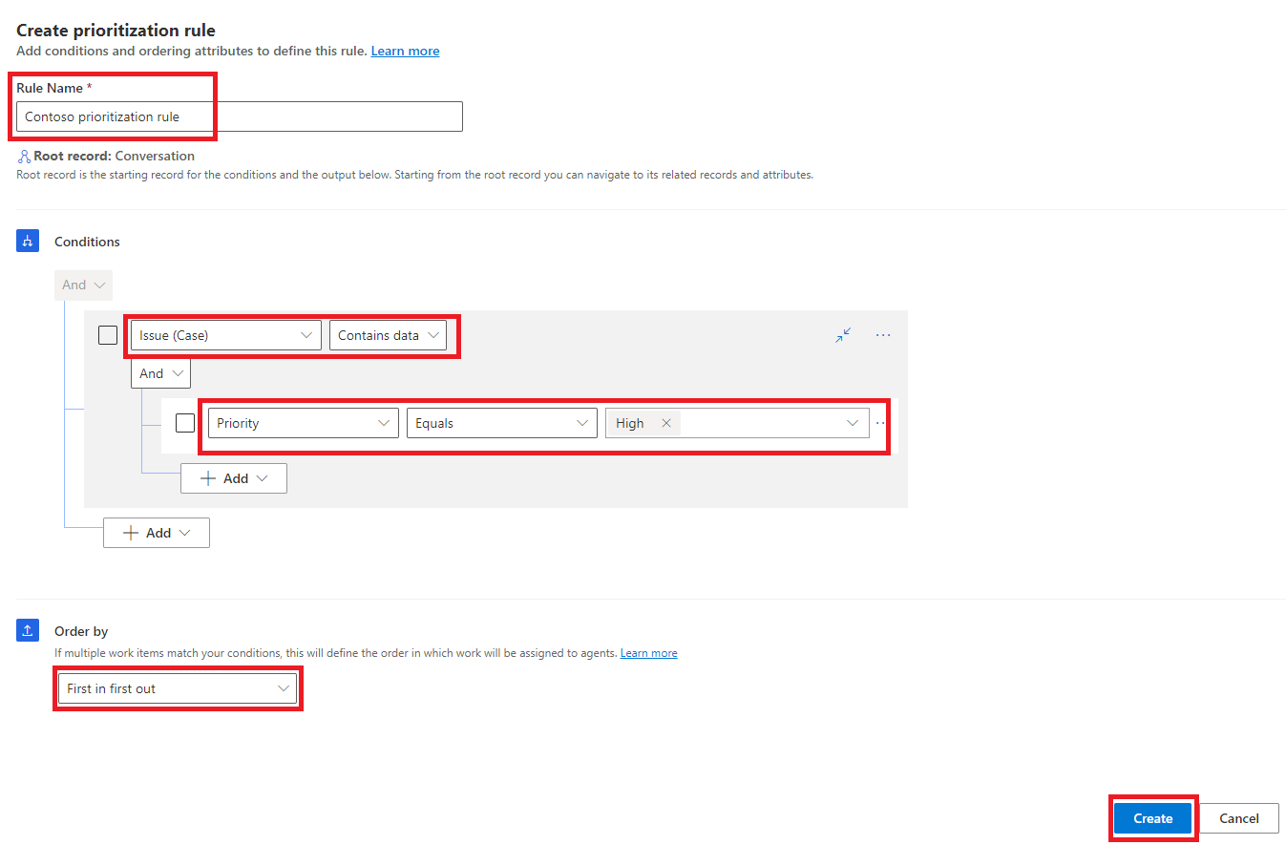
- The Contoso prioritization rule is listed under Decision list.
- 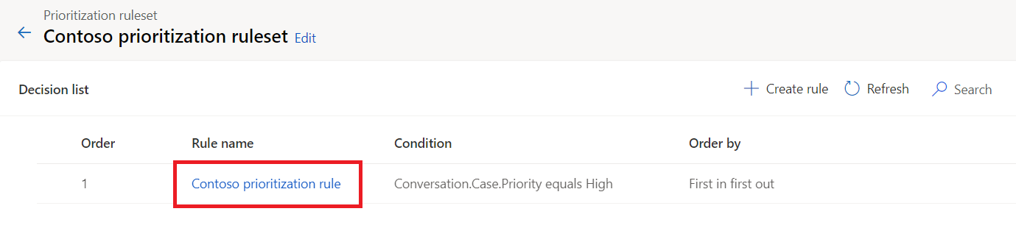
- Click on the Contoso work assignments at the top to navigate back.
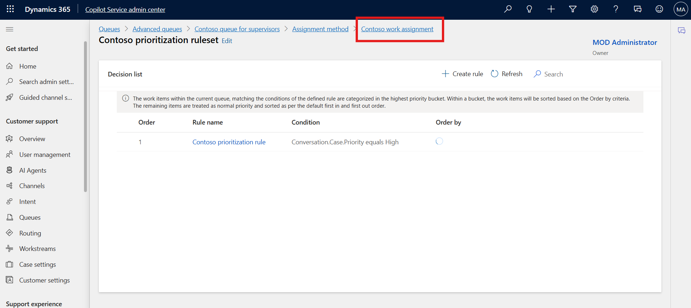
- To create an assignment ruleset, click + Create ruleset on the Assignment rulesets area.
- 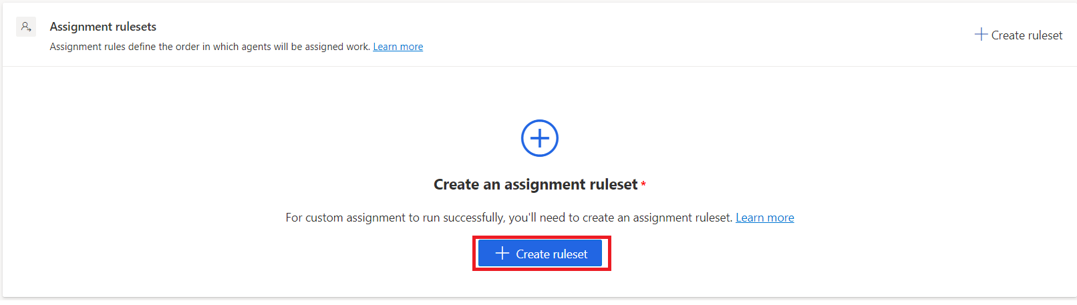
- On the Create Assignment Ruleset dialog, enter !!Contoso assignment ruleset!! in the Name field and Description field.
- Click Create.
- 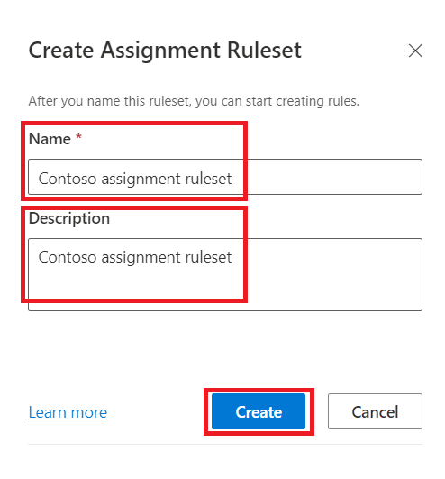
- On the Contoso assignment ruleset page, in the Decision list area, select + Create rule.
- 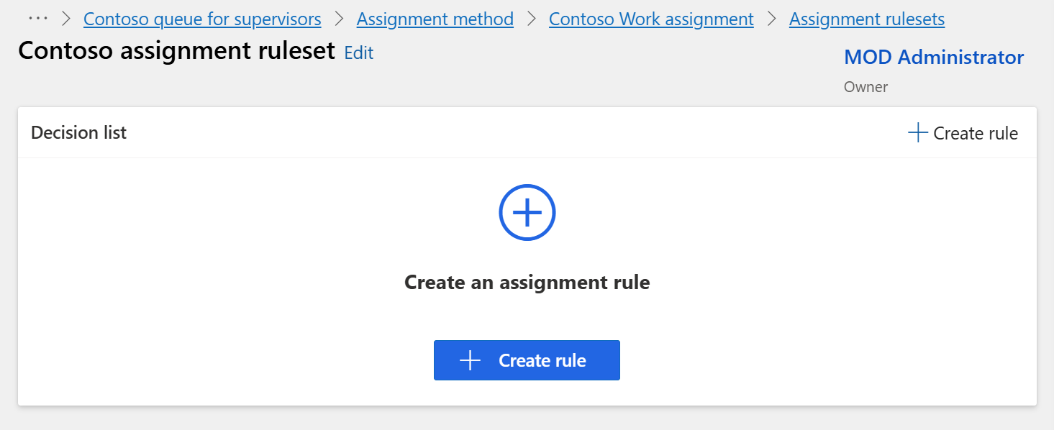
- On the Create Assignment rule page, enter !!Contoso assignment rule!! in the Name field.
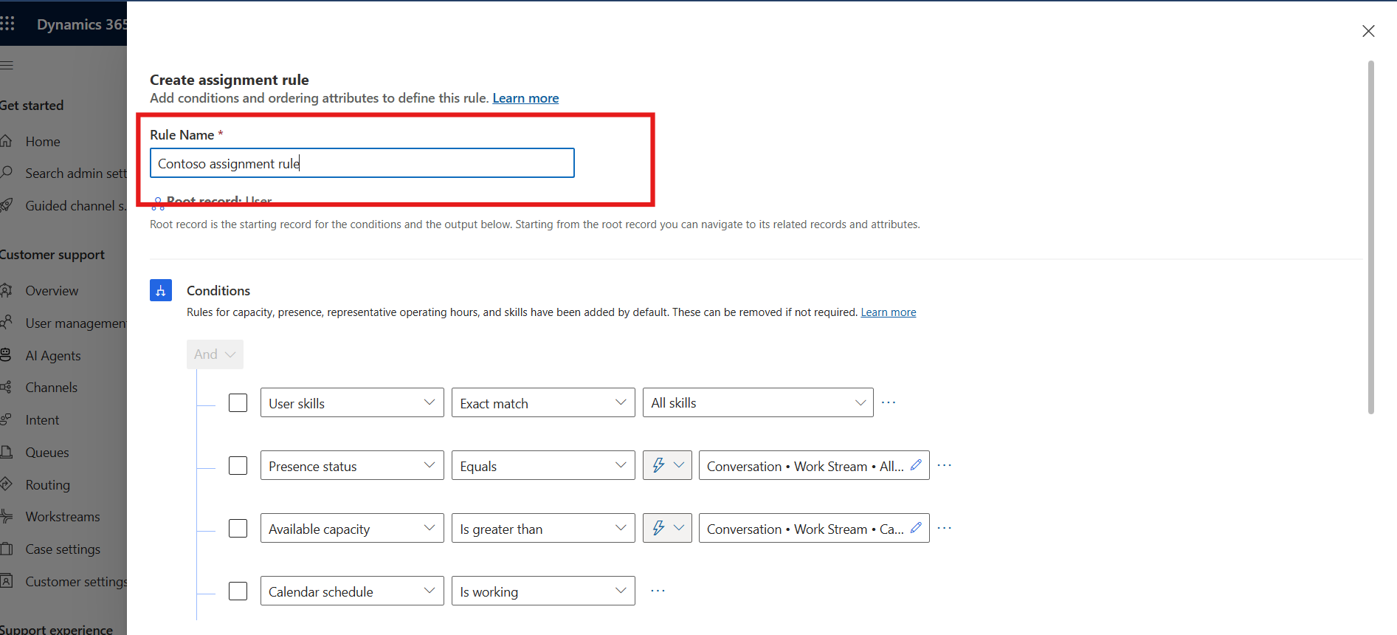
- Click on the ellipsis icon on each condition rule and delete the rules that are already added.
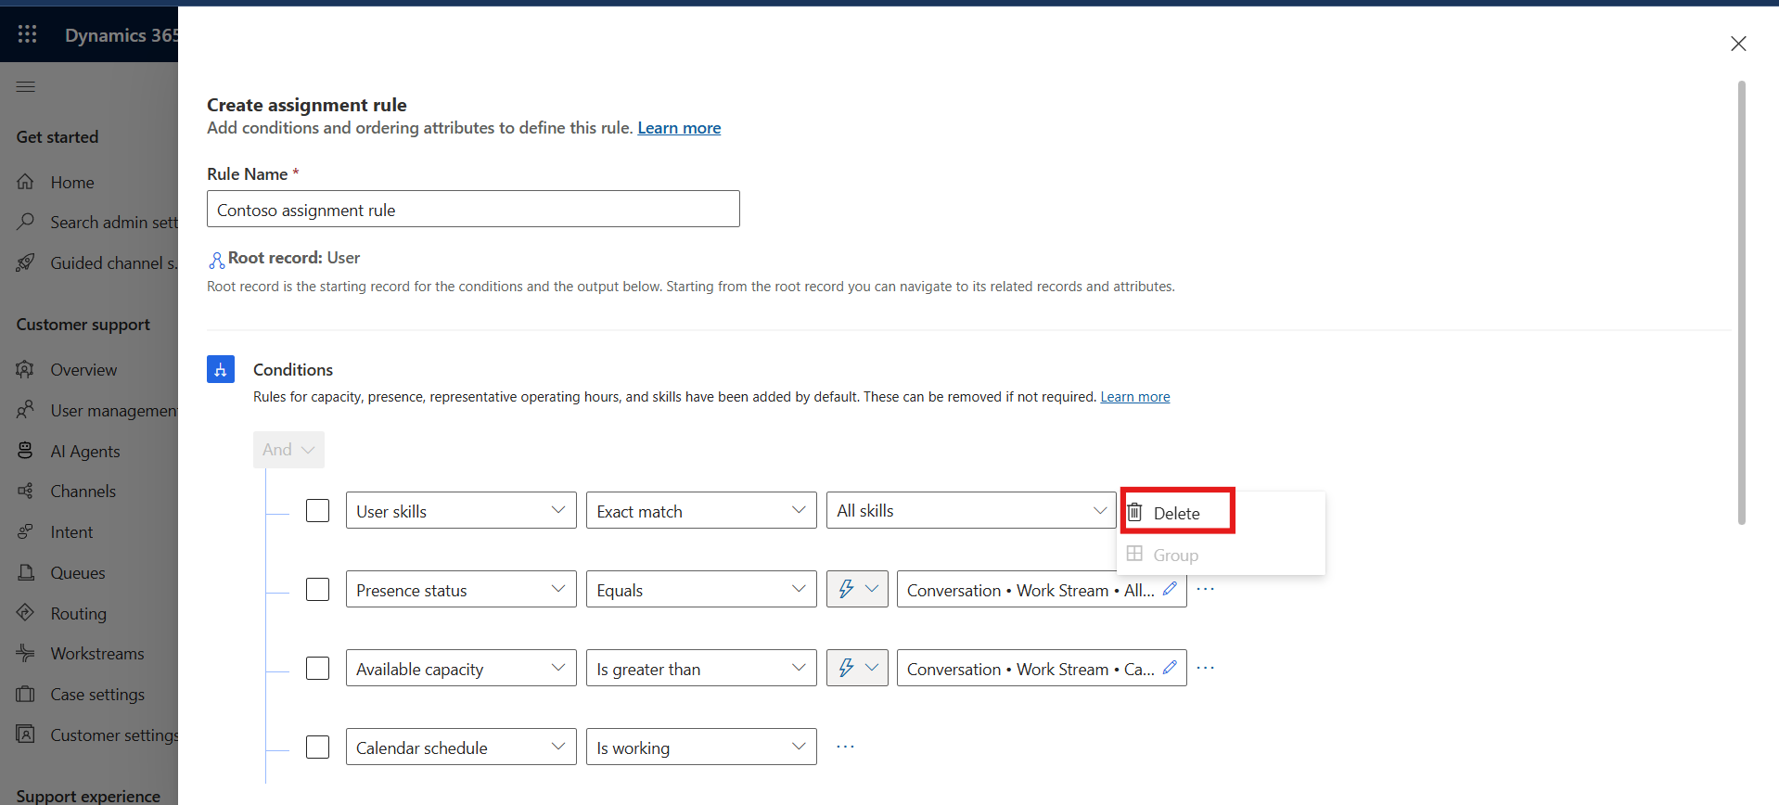
- Select + Add and then select Add row.
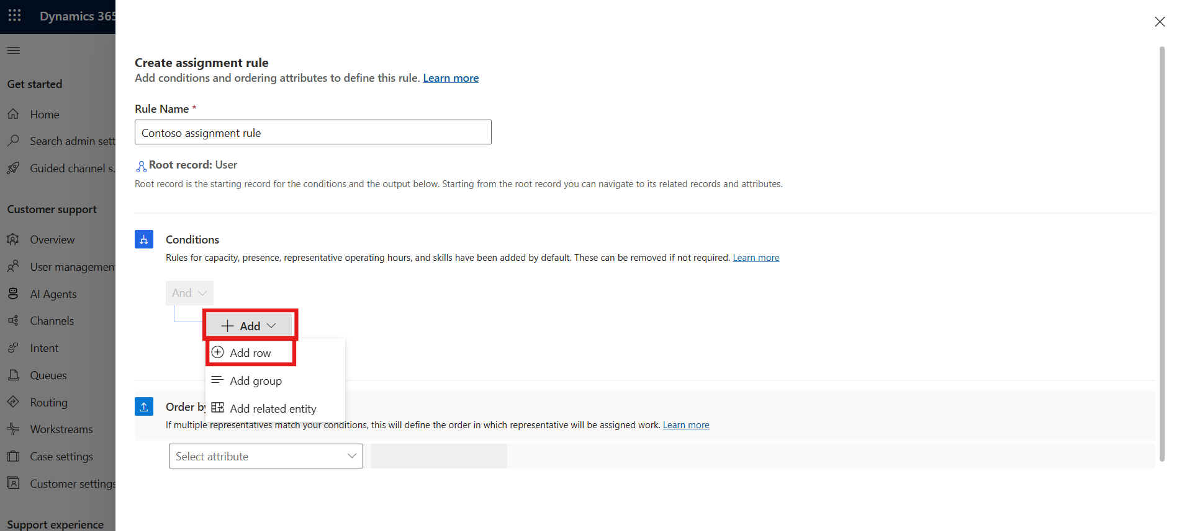
- Create the following condition in the first row: User skills Exact match Skill.
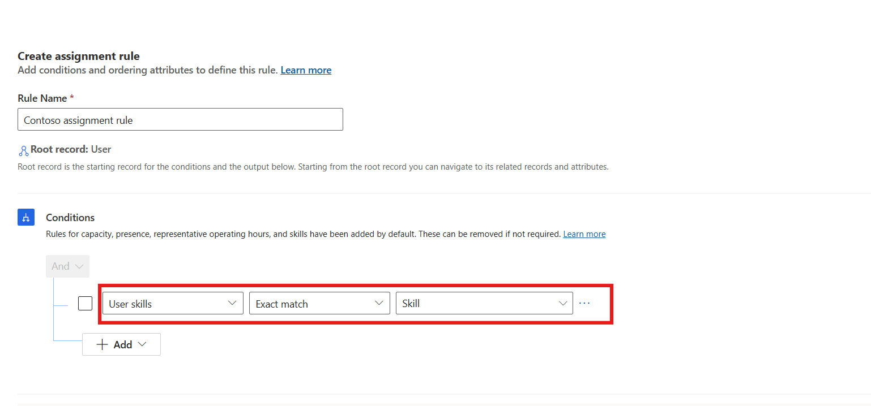
- Select + Add and then select Add group.
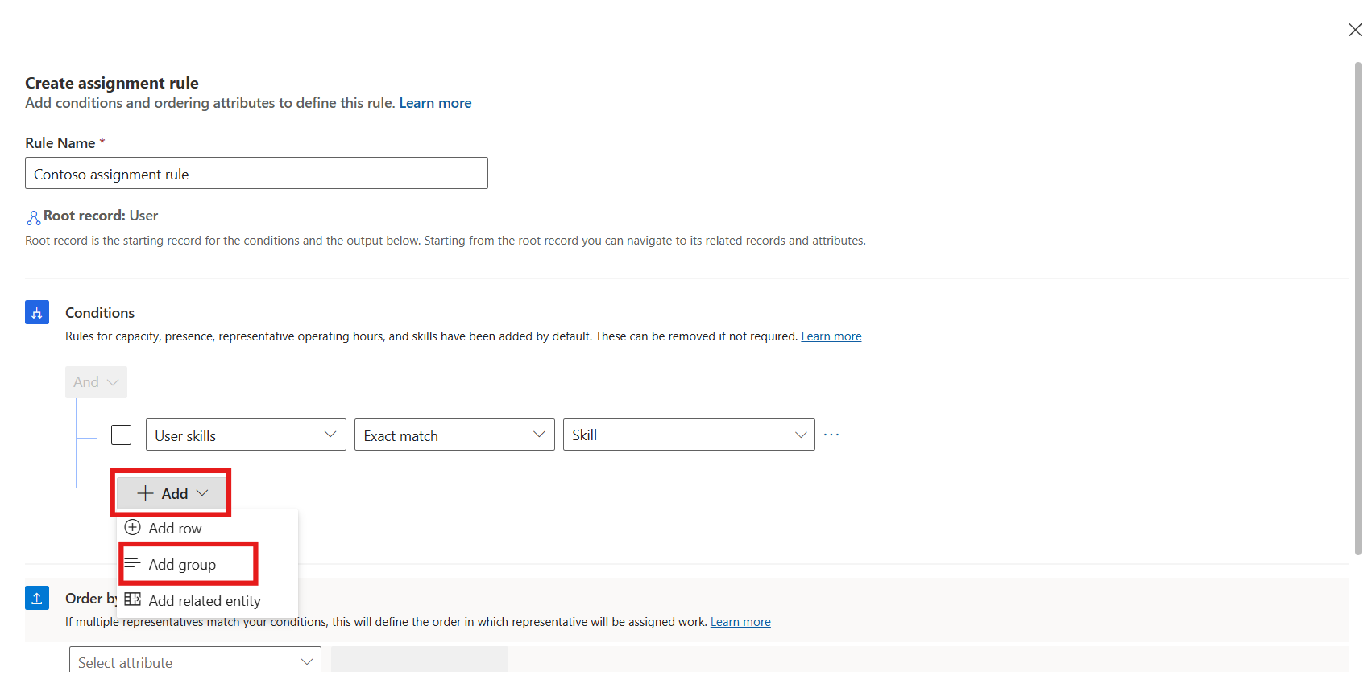
- Create the following condition in the group: Presence status Equals Available, Busy.
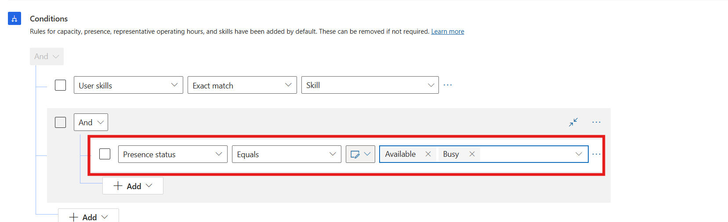
- Select + Add in the group and then select Add row.
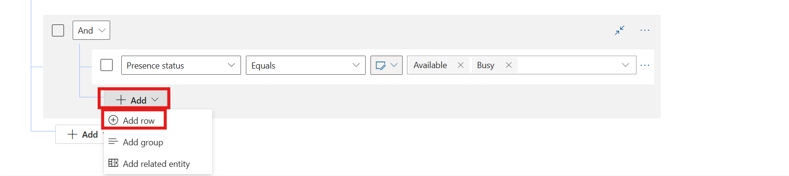
- Create the following condition in the new row: Calendar schedule Is working.
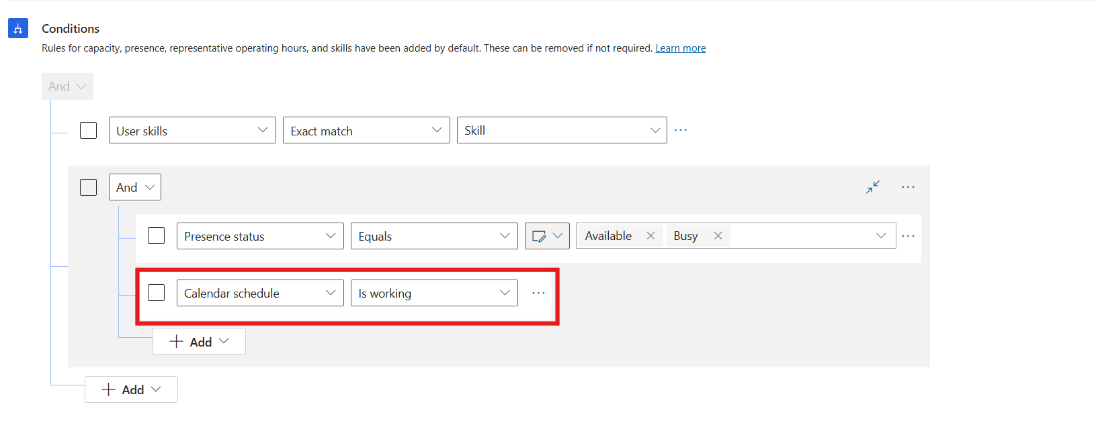
- In the Order by area, select Unit-based available capacity.
- Click Create.
- 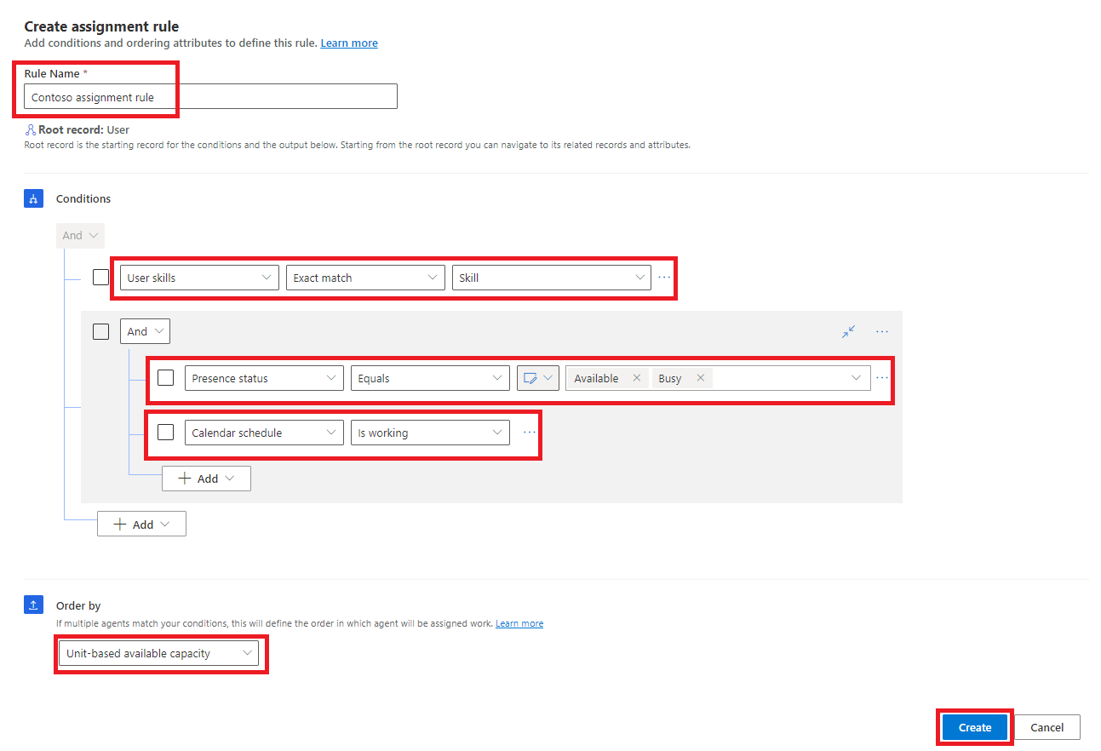
- The Contoso assignment rule is listed under Decision list.
- 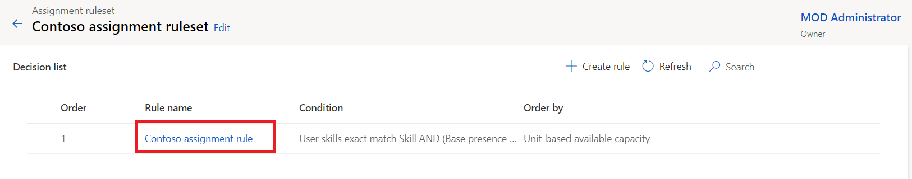

Conclusion:
By completing this lab, you have successfully configured work assignment and prioritization rules in the Copilot Service admin center. These configurations help automate case distribution, prioritize urgent issues, and ensure that agents with the right skills and availability handle customer requests efficiently.

